Quiz Bank for CHEM 6B Experiment 11

Experiment 11 : Multistep Synthesis

- Which of the following would confirm the presence of a bromine atom using MS?
a. [M+1] that is 50% as abundant as [M]
b. [M+1] that is 33% as abundant as [M]
c. [M+2] that is 50% as abundant as [M]
d. [M+2] that is 33% as abundant as [M]
e. [M+2] that is as abundant as [M]

- Based on the mechanism, which reaction would proceed the fastest? (Assume an aqueous work up)

- How would you best separate aniline from naphthalene by extraction?
  - Distillation
  - Chromatography
  - Dissolve in methylene chloride and extract the aniline into an aqueous layer by shaking with 3N NaOH.
  - Dissolve in methylene chloride and extract the naphthalene into an aqueous layer by shaking with 3N HCl.
  - Dissolve in methylene chloride and extract the aniline into an aqueous layer by shaking with 3N HCl.

- Which of the following carbons on the aromatic ring will most likely show the least intensity in ¹³C NMR?
- Which of the following protons will be furthest downfield in a ¹H NMR?
- For the following balanced equilibrium, which side of the equilibrium is favored, and by how much?
  - Right side, 12
  - Left side, 12
  - Right side, 10¹²
  - Left side, 10¹²
  - Left side, 10⁸

1. Which structure fits both the ¹H and the ¹³C NMR spectra found below? The molecular formula is C₄H₈Cl₂.

A | B | C | D
2. Which of the following compounds has three different sets of structurally equivalent hydrogen atoms?
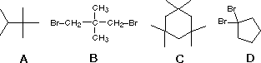

3. Which spectroscopic tool would be best for distinguishing a sample of chlorocyclopentane from bromocyclopentane?
a. ¹H-NMR
b. Infrared spectroscopy
c. Ultraviolet-visible spectroscopy
d. Mass spectrometry

4. Ethers typically fragment to form _____ by _____.
a. Water, γ cleavage
b. An alkoxide, α cleavage
c. An alkoxide, β cleavage
d. An oxonium, α cleavage
e. An oxonium, β cleavage

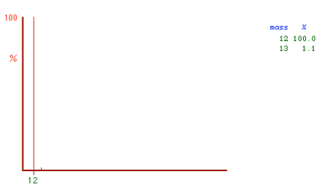
5. In the mass spectrum of graphite above, based on relative isotopic abundance, the [M +1]⁺ peak is a result of:
a. An extra hydrogen
b. An extra deuterium
c. The ¹³C isotope
d. The ¹H isotope

6. The mass spectrum of 3-pentanone has a very large ion peak at m/z = 57. Which of the following ions is thought to be responsible for this peak?
A | B | C | D

7. Use the following spectra to determine the structure of the unknown compound. Partial credit will be given for labeling spectra and identifying key pieces of the molecule.

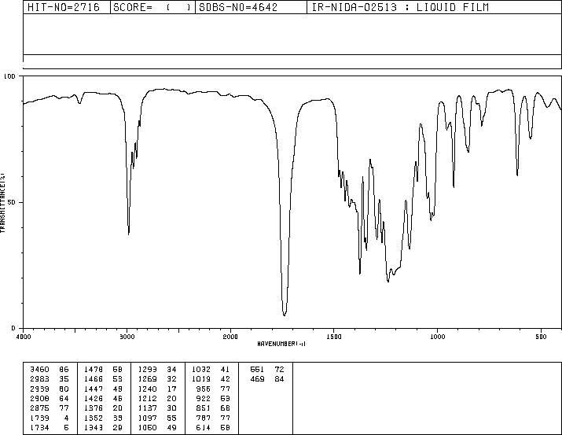 | 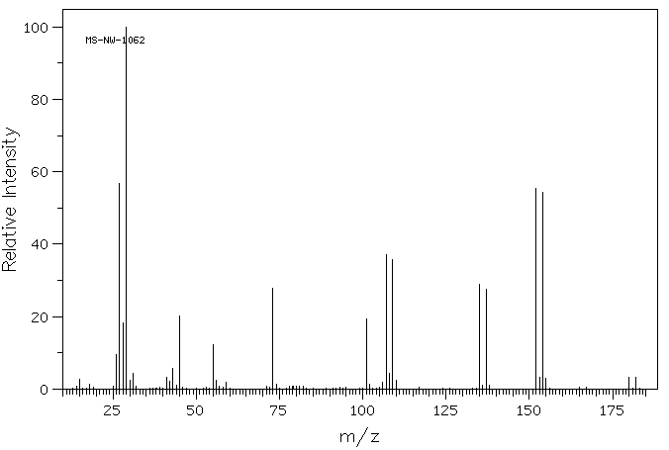
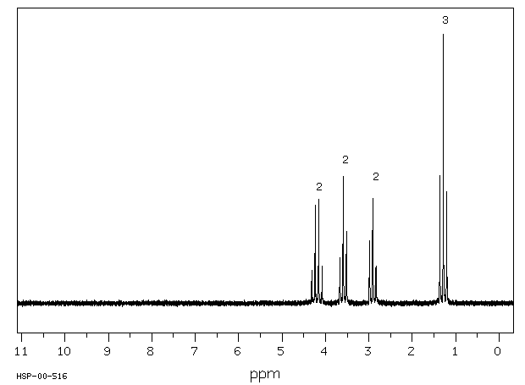 | 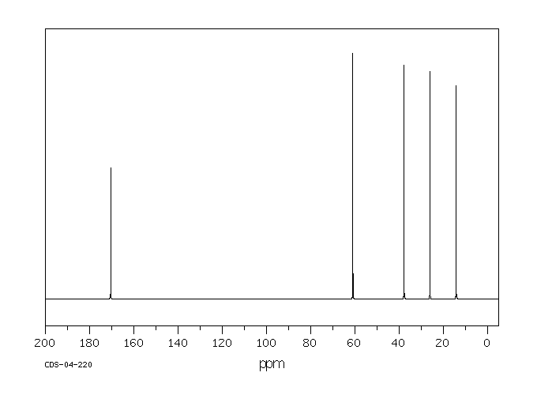

8. Which bond is weaker:
  - C-Br
  - C-Cl
  - neither
  - they’re the same

9. Silica bearing a ________ mesh size will give better separation.
- Larger
- Smaller
- Negative
- Zero
10. C-H stretches for sp² and sp carbons show up at _________, while C-H stretches for sp³ carbons show up at _________?

- 3400-3100 cm⁻¹, 2200-2000 cm⁻¹
- 3100-3000 cm⁻¹, 3000-2850 cm⁻¹
- 3000-2600 cm⁻¹, 2200-2000 cm⁻¹
- 2200-2000 cm⁻¹, 1100-600 cm⁻¹

